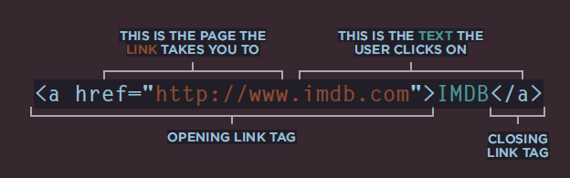

-----

Sample1

------

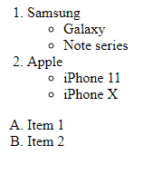

-----

Sample2

------



-----

Sample3

------



-----

Sample4

<h1 id="id1">This is starting of the page</h1>

<a href="#id1">Go to Top</a>

------

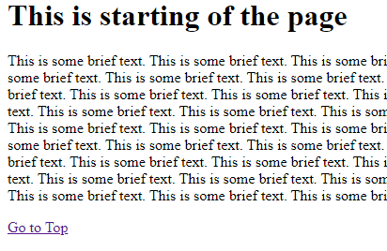

-----

Sample5

------

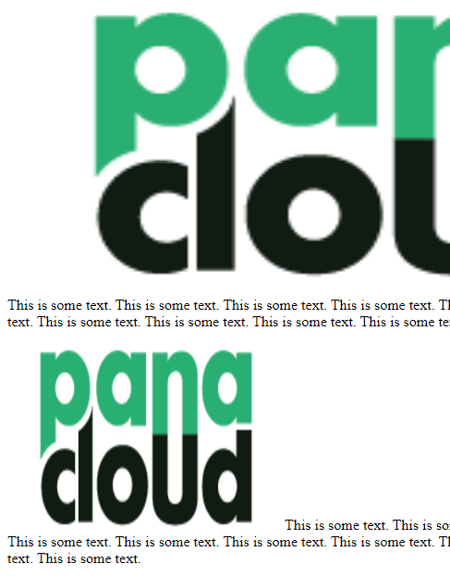

-----

Sample6

------

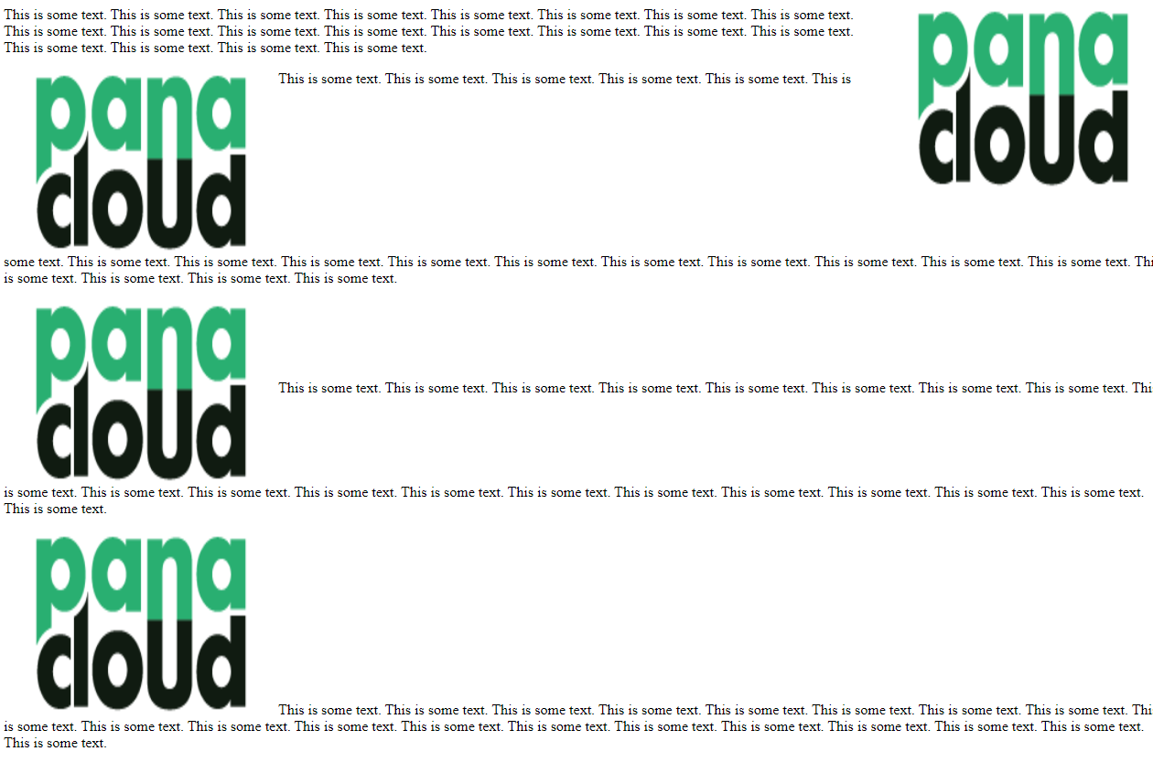

-----

Sample7

------



-----

Sample8

------

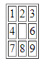

-----

Sample9

------

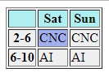

-----

Sample10

------

